PHYS1110D – Engineering Physics: Mechanics and Thermodynamics

Tutorial Problems for Week 8: Energy and Linear Momentum

**Problem 1 – Potential Energy and Force**

A particle moving on the $x$-axis has potential energy (unit: Joule; unit of $x$: meter)

$$U\left(x\right)=\frac{1}{4}x^{4}-2x^{2}$$

1. What is the force on this particle at position $x$? Please specify the direction of the force.
2. Suppose the particle is initially at position $x=-2 \text{m}$ with zero velocity. What is the minimum kinetic energy required for the particle to be able to reach $x=2 \text{m}$?

**Problem 2 – Center of Mass**

Two blocks A (mass $m_{A}=3 \text{kg}$) and B (mass $m_{B}=2 \text{kg}$) are tied to a rope hanging over through two frictionless pulleys. There is also no friction between the rope and the pulleys. The blocks are moving due to the downward gravity force (acceleration due to gravity $g=10 \text{m/}{\text{s}}^{\text{2}}$). Neglecting the mass of the pulleys and the rope, please find the *total* force (including magnitude and direction) exerted by the two pulleys on the rope.

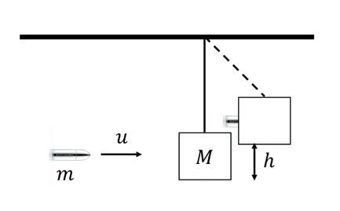**Problem 3 – Collision**

A pendulum with a block of mass $M$ is set up as shown in the figure below. A bullet of mass $m$ and speed $u$ is fired towards the block. The bullet embeds in the block and the entire system swings to a height $h$. Express $h$ in terms of $M$, $m$, and $u$.

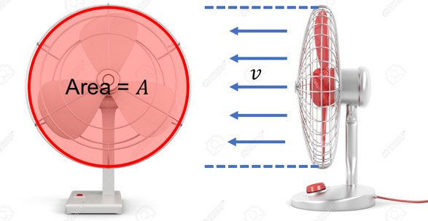**Problem 4 – Impulse, Momentum and Force**

A fan is inhaling air (initial velocity is zero) and blowing it out at constant velocity $v$ towards its front (see the figure). The density of the air is $ρ$ (treating it as a constant). What is the extra pressure (force per unit area) exerted by the air on the fan leaves? (By *extra* we mean that the atmosphere pressure should be deducted.)